 Franciscan Solutions Pvt Ltd

Accounts Module

1.1 Search Menu
The "Search Menu" feature allows users to search for any tab or sub-tab by name. It simplifies navigation by quickly locating desired options within the module.
🧭 Where to Find It
Navigate to:
Account Module → Search Menu
✅ Use Case
If a user wants to jump directly to "Voucher Print Setting" or "Narration Master", they can just type the name in the search bar instead of browsing manually.
⚠️ Important Notes
- Works module-wide.
- Helps save time especially in large systems.
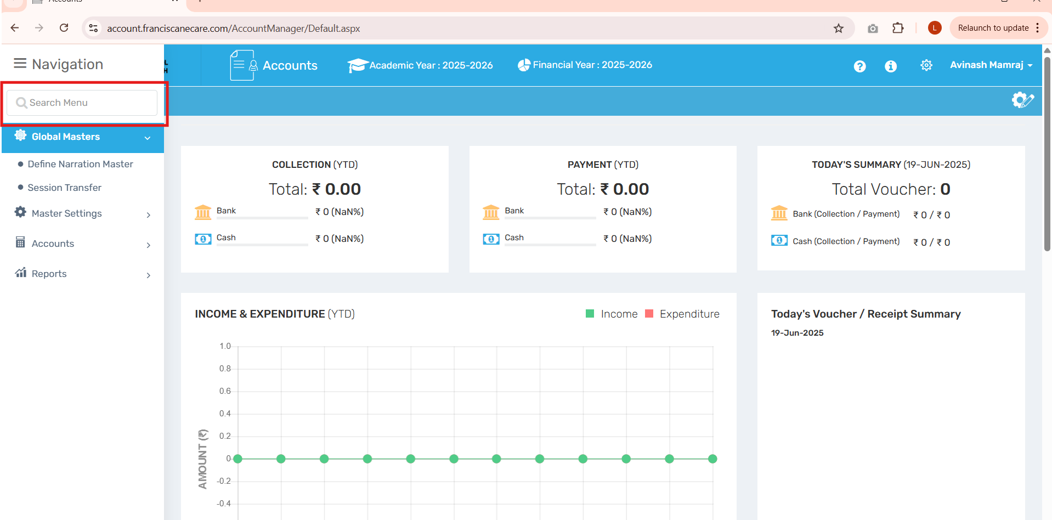

1.2 Global Master → Define Narration Master
The "Define Narration" tab is used to create predefined narrations for different types of vouchers, especially for Cash Payment Vouchers. This saves time and standardizes descriptions across the system.
🧭 Where to Find It
Navigate to:
Account Module → Global Master → Define Narration Master
✅ Use Case
Helps users insert frequently used narration like “Cash paid for purchase of books” without typing it each time.
⚠️ Important Notes
- Improves consistency in voucher entries.
- Useful for internal audit and review.
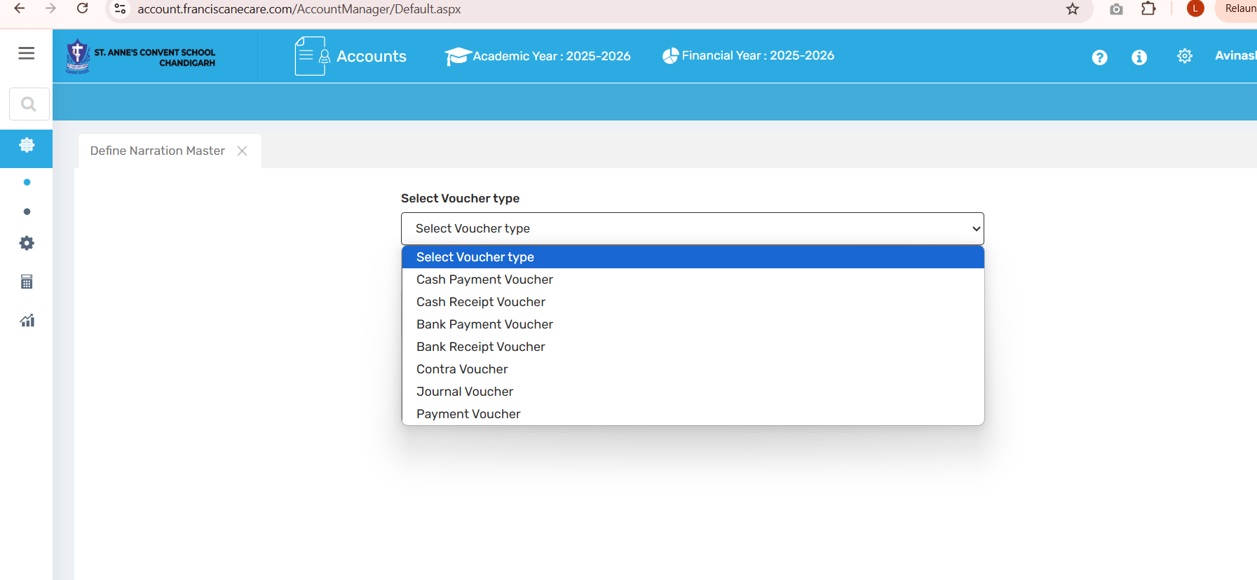

1.2 Session Transfer
The "Session Transfer" feature is used to copy essential account setup data like ledgers, voucher settings, and group structures from the current academic and financial year to the next academic year. It ensures continuity and reduces manual re-entry for the new session.
🧭 Where to Find It
Navigate to:
Account Module → Session Transfer
✅ Use Case
Easily carry forward account structures to the next academic year without recreating them manually.
⚠️ Important Notes
- Data marked Already Transferred cannot be transferred again.
- Items marked Not Transferred still need to be pushed to the new session.
- Always double-check target academic year before initiating transfer.
- Financial entries (like transactions) are not transferred—only structural/account setup is.
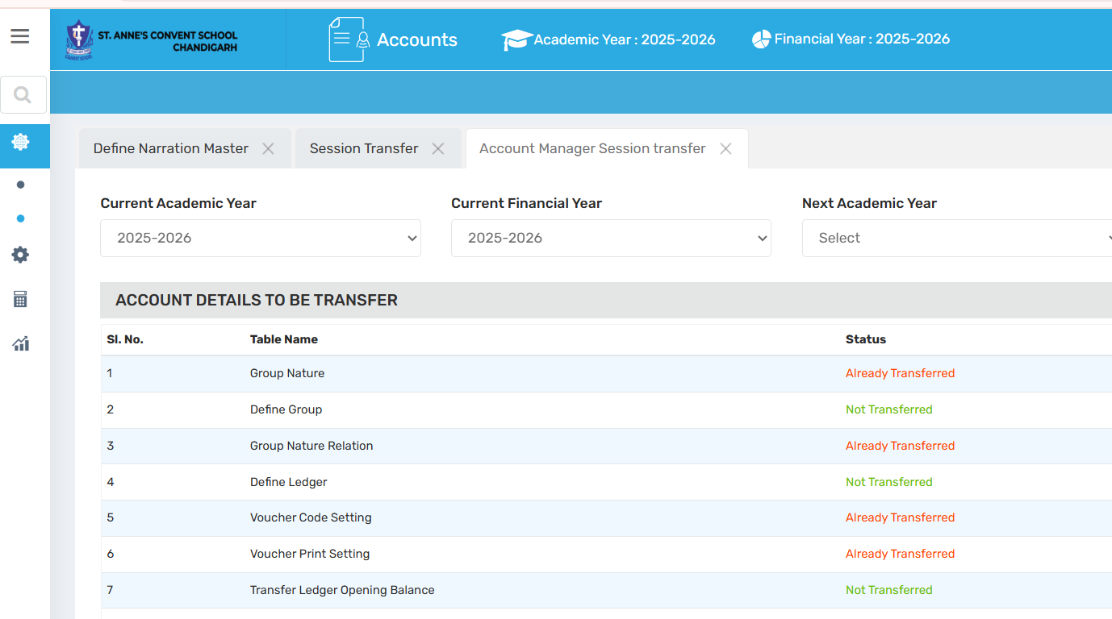

1.3 Master Setting → Change Academic Year Setting
The "Change Academic Year Setting" allows switching to a different academic session for financial data entry and viewing.
🧭 Where to Find It
Navigate to:
Account Module → Master Setting → Change Academic Year Setting
✅ Use Case
Helps users manage vouchers or financial records for the past or next academic year without affecting other users.
⚠️ Important Notes
- Session-specific and user-specific change.
- Does not globally affect software settings.
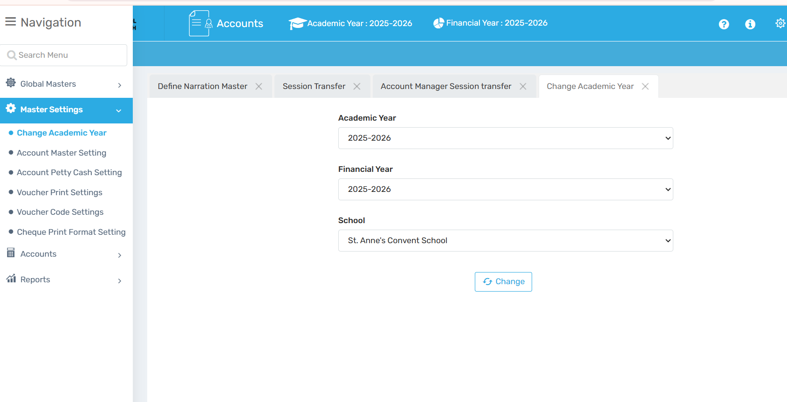

1.4 Master Setting → Account Master Setting
"Account Master Setting" allows configuring different voucher-related preferences as per school requirements.
🧭 Where to Find It
Navigate to:
Account Module → Master Setting → Account Master Setting
** Field Description
Field / Button | Description
Select Ledger | - To choose the default ledger for accounting entries.  - Example: If "FEE COLLECTION" is selected, all related transactions will be recorded under that ledger.
Is Accrual Based Accounting | - Purpose: Enables or disables accrual accounting, where income and expenses are recorded when they are earned or incurred, not when cash is exchanged.  If Checked: Accounting will follow accrual method (more accurate for financial reporting).  .
Select Head | Purpose: Choose the fee head (like tuition fee, admission fee, etc.) to be linked with accrual-based entries.  Example: You can assign "Tuition Fee" as the head for tracking receivable entries.
Create Fee Dues | - Purpose: Button to generate fee dues as per the selected accrual-based head.
Is Narration Mandatory | - Purpose: If enabled, users must enter a narration (description) while creating any voucher.  - Advantage: Helps maintain transparency and audit clarity in each transaction.
Negative Balance Allow | Negative balance allow on cash payment voucher?  - Purpose: Controls whether the system should allow vouchers even when the balance goes negative.  - If Enabled: User can make payments even if the ledger does not have sufficient funds.  - If Disabled (as shown): Negative balances are not allowed to prevent overdraw.
Hide Cheque Details on JV | - JV = Journal Voucher  - Purpose: If enabled, cheque details (like number, date) will be hidden in journal vouchers.  - Advantage: Some schools prefer to record journal entries without cheque info.
Serialize Voucher Code | - Purpose: Enables the option to generate serial numbers for vouchers, which helps in tracking and organizing them.  - Example: Voucher codes like CPV001, CPV002, etc., are created automatically.  .
P&L Ledger for Balance Sheet | Set ledger for Profit & Loss in Balance Sheet.
✅ Use Case
Admin can control voucher behavior, set ledger defaults, and manage printing preferences to align accounting with internal policies.
⚠️ Important Notes
- Should be configured carefully by an admin.
- Affects how transactions are recorded.
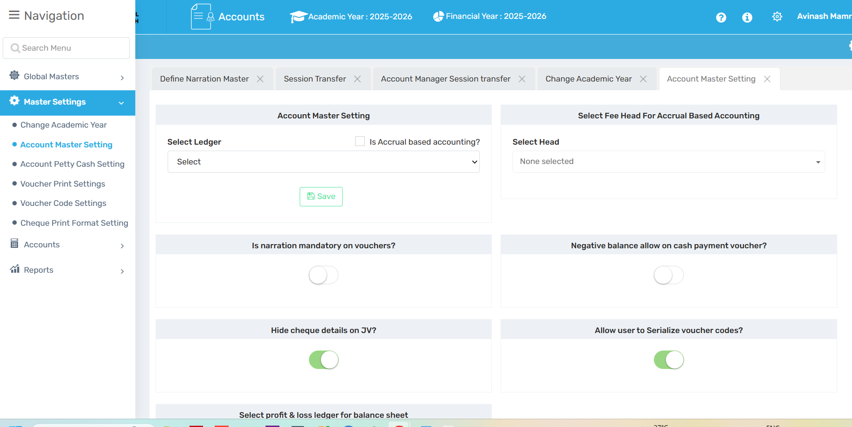

1.5 Quick Link
This tab allows users to add shortcuts to top of the module for quicker access to frequently used features.
🧭 Where to Find It
Navigate to:
Account Module → Quick Link
✅ Use Case
Add “Cash Voucher” or “Bank Ledger” as quick links for easy access during busy hours.
⚠️ Important Notes
- Shortcuts are user-specific.
- Doesn’t affect other users’ interface.

1.6 Account Petty Cash Setting
Petty Cash is a small cash fund for minor day-to-day expenses.
🧭 Where to Find It
Navigate to:
Account Module → Petty Cash
Account Petty Cash Setting
✅ Use Case
Use for small purchases like stationery, delivery, or snacks.
⚠️ Important Notes
- Select the correct ledger to manage petty cash tracking.
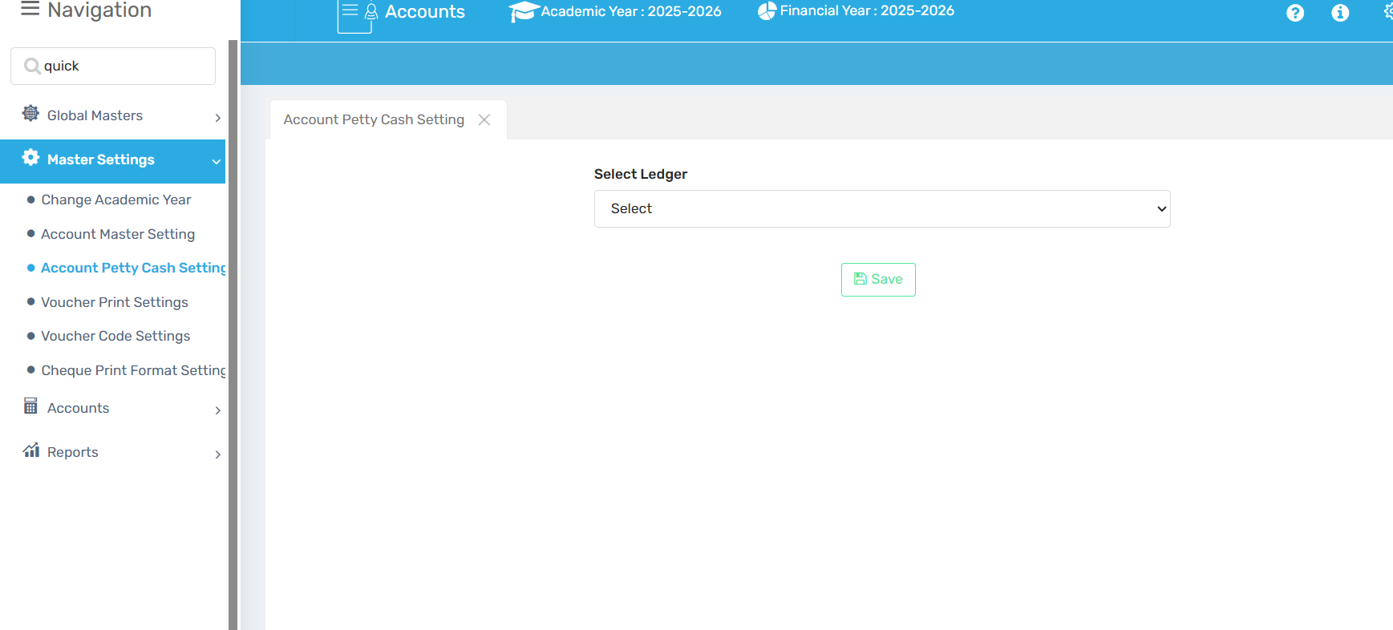
1.7 Voucher Print Setting
This setting controls how vouchers are printed.
🧭 Where to Find It
Navigate to:
Account Module → Voucher Print Setting
** Field Description
Option | Description
Without Receipt | Only the voucher will print.
With Receipt | Voucher + receipt will print.
Yes/No Option | User can choose to print receipt or not.
✅ Use Case
Customizes printing preference based on school’s reporting style.
⚠️ Important Notes
- Make sure printer format matches setting.
Validate Voucher Entry with Same Ledger
Prevents users from creating vouchers where debit and credit ledgers are the same.
🧭 Where to Find It
Account Module → Account Master Setting
✅ Use Case
Avoids data entry errors in journal/accounting.
⚠️ Important Notes
- Helps maintain accurate ledger records.
Signing Authority Setting
Define label names and positions for voucher signatories.
🧭 Where to Find It
Account Module → Signing Authority Setting
** Field Description
Option | Description
Is Show on Report? | Tick to show signature block on print.
✅ Use Case
This section defines the labels and positions that will appear for signatures on printed vouchers.
The “Is show on report?” checkbox means the title/signature will be printed on the Report
⚠️ Important Notes
- Ensure proper designation is selected.
Voucher Format Setting
Choose how each voucher type is printed—layout, spacing, style.
🧭 Where to Find It
Account Module → Voucher Format Setting
✅ Use Case
Custom formats as per school preference (e.g., single vs. dual copy).
Voucher Code Setting
Set custom voucher codes and allow editing of backdated vouchers.
🧭 Where to Find It
Account Module → Voucher Code Setting
✅ Use Case
The user can set the voucher code from here and allow to edit the voucher code or change the voucher code in back date.

1.7 Cheque Print Formatting Setting
Set layout for printing cheques directly from software.
🧭 Where to Find It
Account Module → Cheque Print Formatting Setting
✅ Use Case
The user can set the format of the cheque.
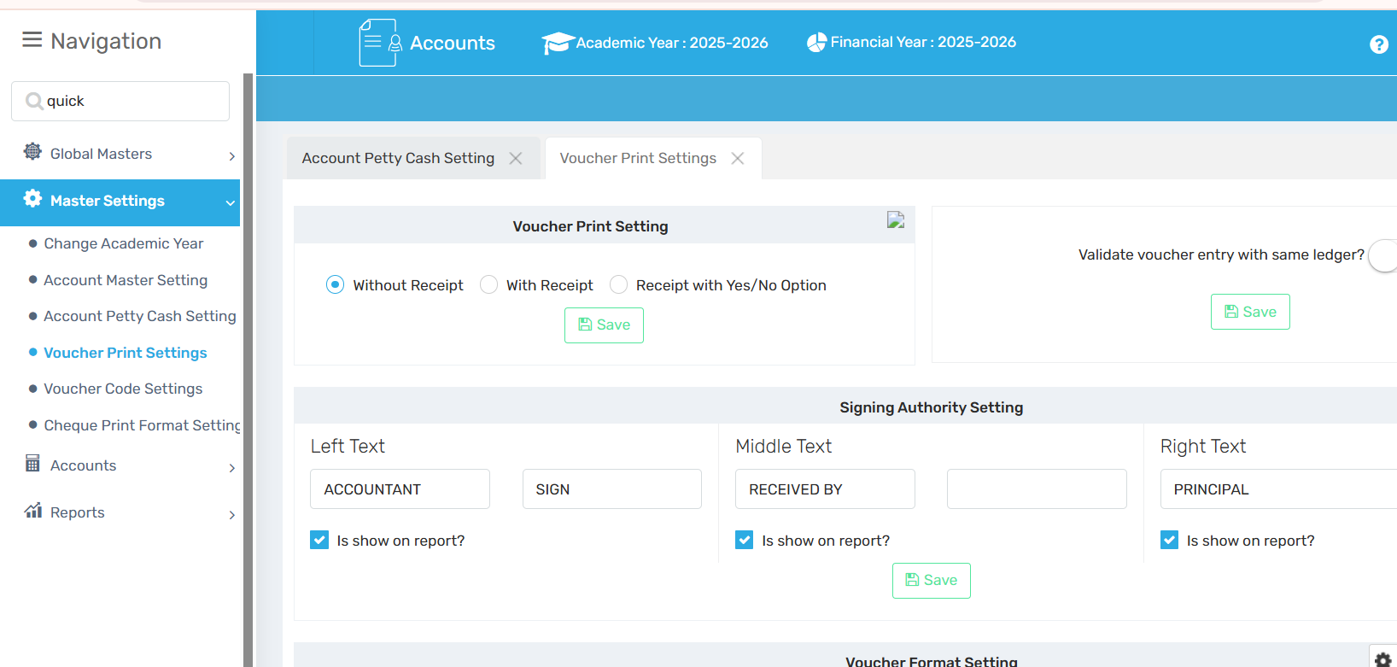

2.1 Accounts → Define Account Group
This feature is used to create account groups and assign categories and group types like Assets, Liabilities, Bank, or Fees.
🧭 Where to Find It
Navigate to:
Account Module → Accounts → Define Account Group
✅ Use Case
Group ledgers properly for better report generation and easier management.
⚠️ Important Notes
Helps in categorizing ledgers correctly for Trial Balance, Balance Sheet, etc.
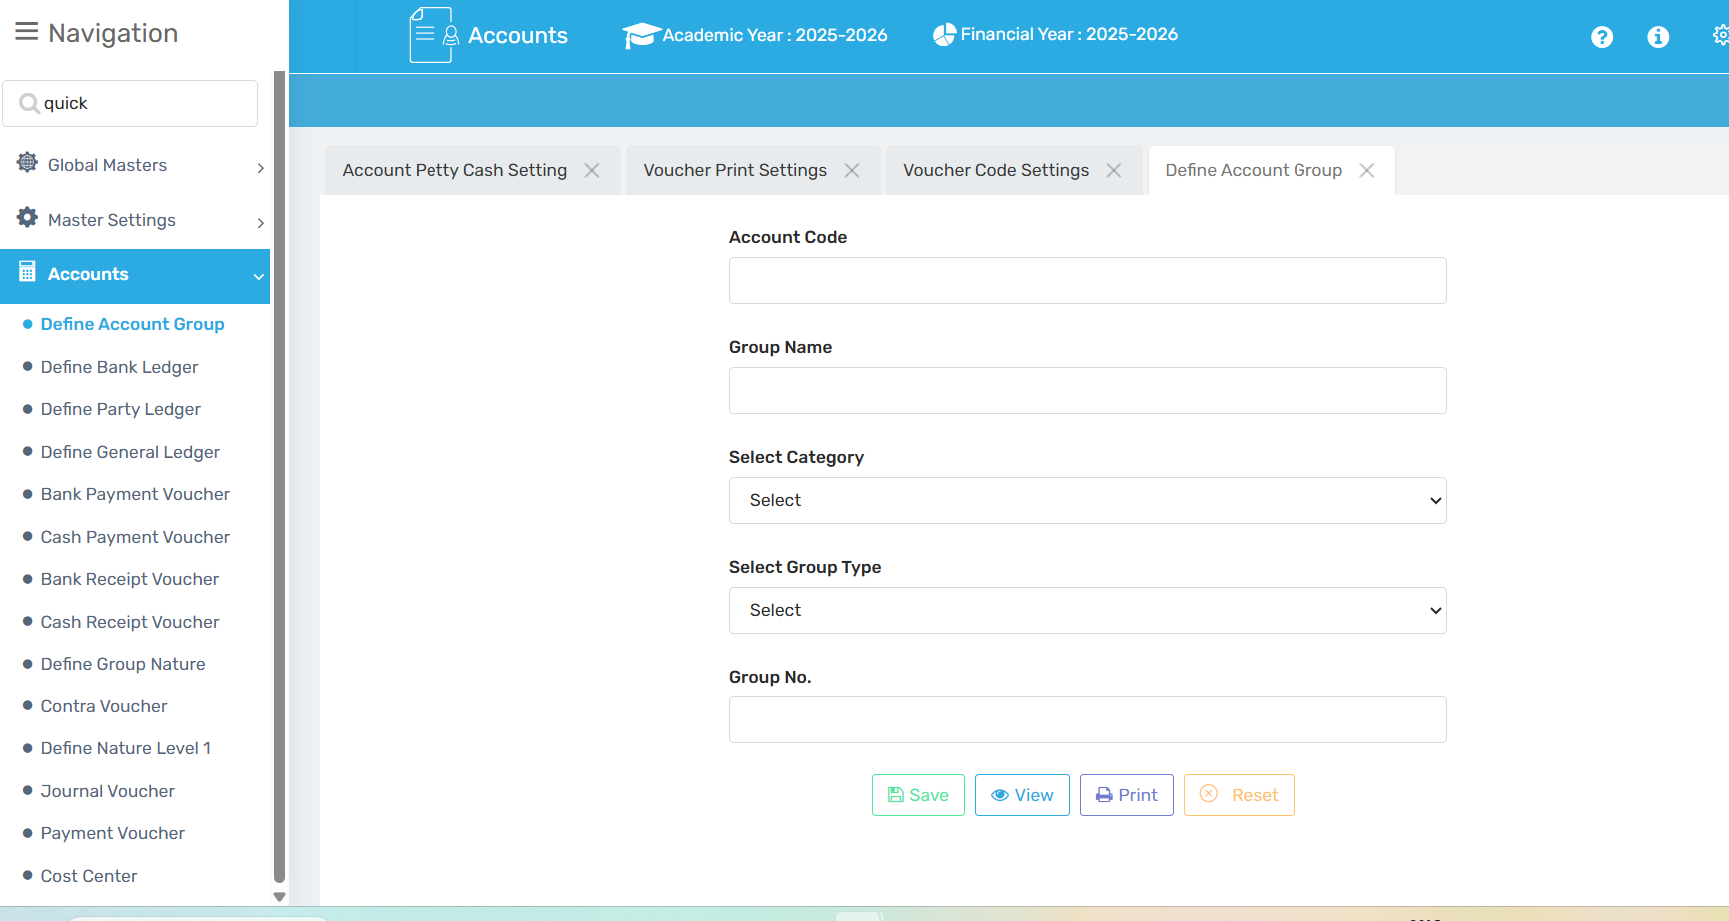

2.2 Accounts → Define Bank Ledger
Here you can define and manage school bank accounts for accounting purposes.
🧭 Where to Find It
Navigate to:
Account Module → Accounts → Define Bank Ledger
✅ Use Case
Track fees or payments done via bank transfer, NEFT, cheque, etc.
⚠️ Important Notes
Correct bank mapping ensures smooth reconciliation and reporting.
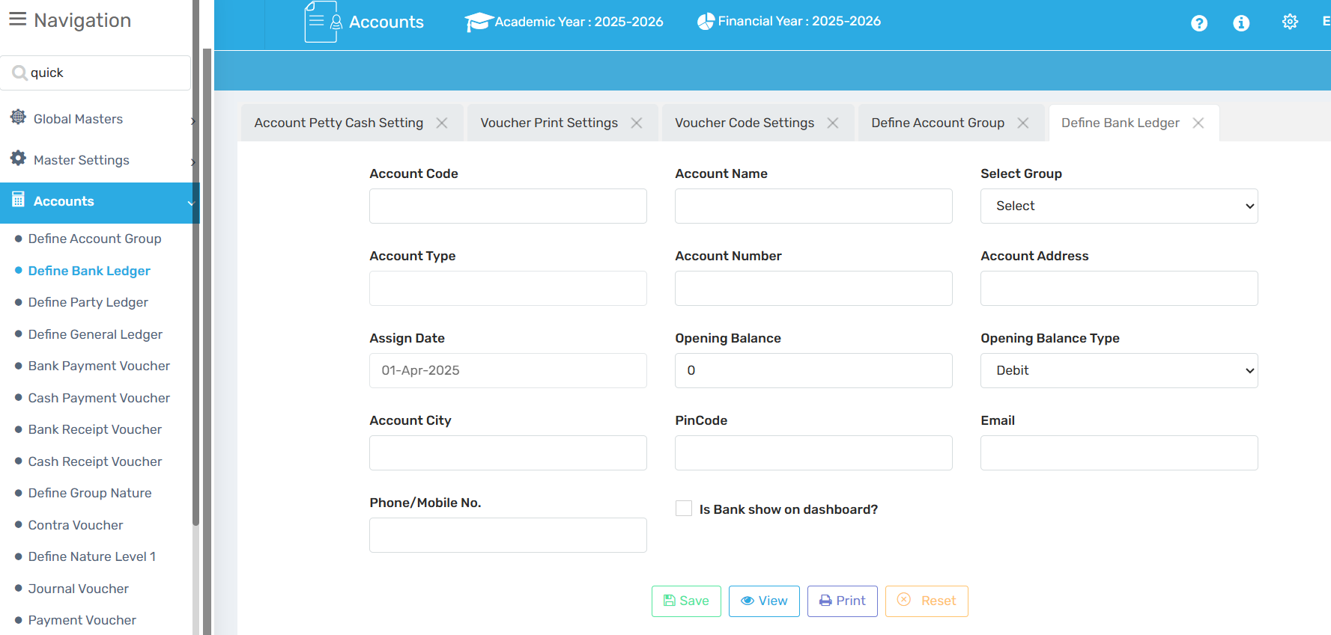

2.3 Accounts → Define Party Ledger
Used to manage records of transactions with individuals or organizations (like vendors or parents).
🧭 Where to Find It
Navigate to:
Account Module → Accounts → Define Party Ledger
✅ Use Case
Record of financial transactions with a specific party (customer or supplier). It tracks what you owe them or what they owe you.
⚠️ Important Notes
Ensure correct party type selection (creditor, debtor, etc.) to maintain ledger clarity.
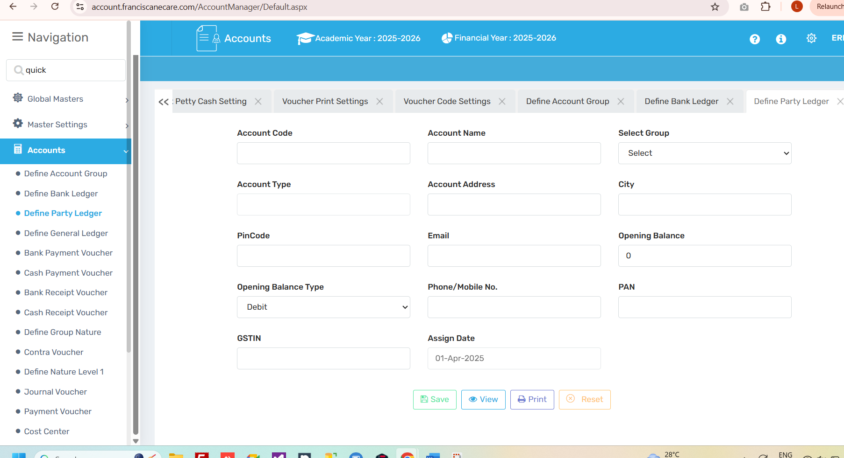

2.4 Accounts → Define General Ledger
This is used for defining general accounting heads which are not related to parties or banks.
🧭 Where to Find It
Navigate to:
Account Module → Accounts → Define General Ledger
✅ Use Case
For Deﬁning General leger details (Not relate to party and bank ledger). A General Ledger is the main accounting record that keeps track of all financial transactions of a business. It shows where money is coming from and where it is going.
⚠️ Important Notes
Essential for tracking operational and administrative expense heads.
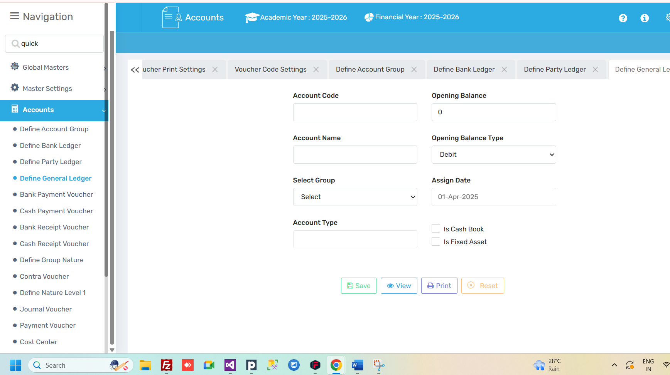

2.5 Bank Payment Voucher
Used when payment is made through a bank account (via cheque, NEFT, etc.).
🧭 Where to Find It
Navigate to:
Account Module → Bank Payment Voucher
✅ Use Case
Advantage: When a school or office pays money through cheque, NEFT, or bank transfer — this voucher is used to record the transaction.
⚠️ Important Notes
Attach bank proof or UTR number in narration for audit clarity.
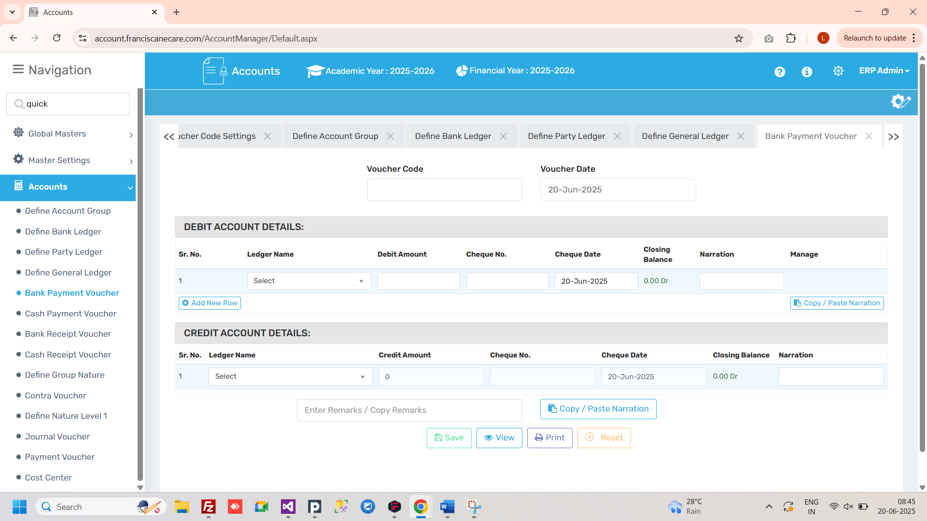

2.6 Cash Payment Voucher
Used for making payments in cash.
🧭 Where to Find It
Navigate to:
Account Module → Cash Payment Voucher
✅ Use Case
A Voucher used when payment is made in cash.
⚠️ Important Notes
Avoid high-value cash entries to comply with audit norms.
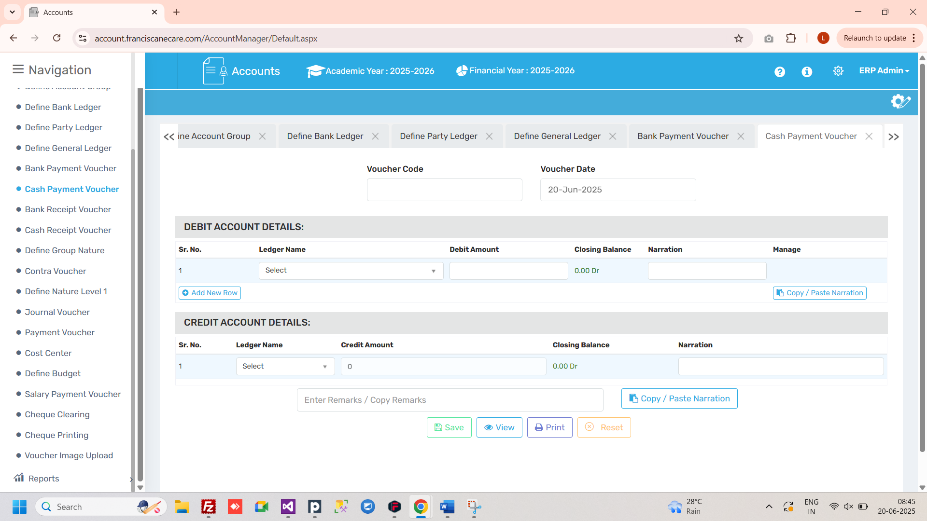

2.7 Bank Receipt Voucher
Records any amount received in the school’s bank account.
🧭 Where to Find It
Navigate to:
Account Module → Bank Receipt Voucher
✅ Use Case
Record student fees received via bank transfer.
Advantage: If someone pays you through the bank (like fees ), it is recorded using this voucher.
⚠️ Important Notes
Enter correct bank and student/party ledger to avoid mismatch.
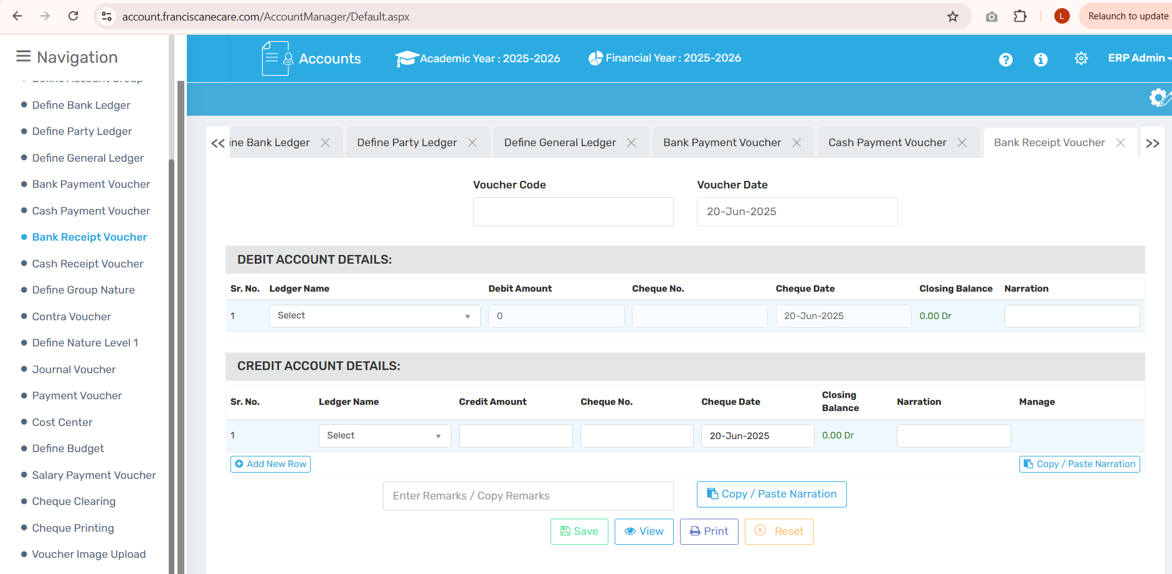

2.8 Cash Receipt Voucher
Used for recording cash received by the school.
🧭 Where to Find It
Navigate to:
Account Module → Cash Receipt Voucher
✅ Use Case
A Voucher for recording money received in cash.
Explanation: If you get money in hand (cash), this voucher is used to note that income
⚠️ Important Notes
Issue physical receipts when accepting large cash payments.
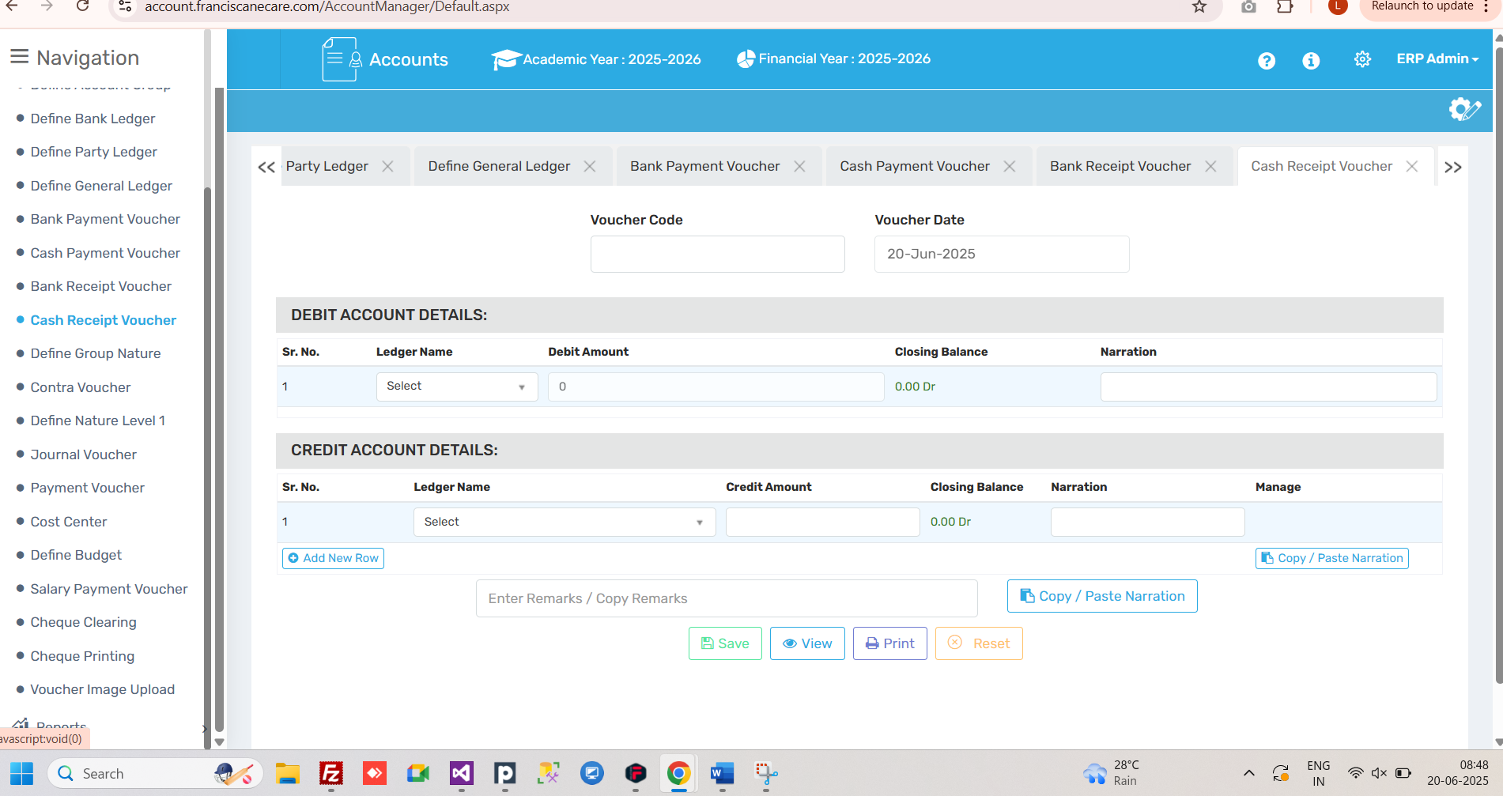

2.9 Define Group Nature
Helps organize ledgers into types like Bank, Party, Cash, Fees, etc., for proper reporting.
🧭 Where to Find It
Navigate to:
Account Module → Define Group Nature
✅ Use Case
It helps organize your ledgers into categories like Bank, Cash, Party, Fees, etc., so reporting and tracking becomes easy.
When you define a new ledger, you can assign it to one of these Group Natures so that:
- Reports (like balance sheet, trial balance) are correctly generated.
- Accounts stay well-organized.
- The system knows how to treat the ledger (as cash, bank, income, expense, etc.)
⚠️ Important Notes
Crucial for correct grouping in Trial Balance and Balance Sheet.
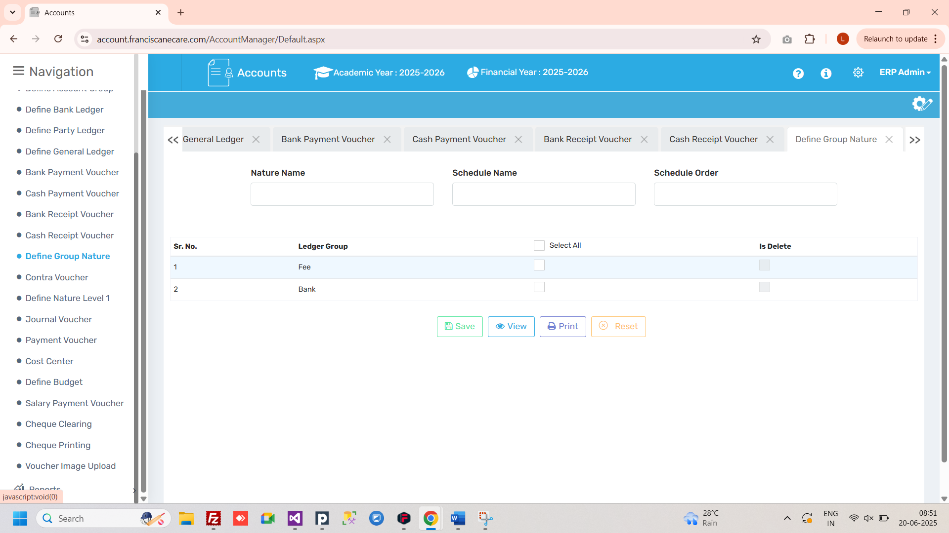

2.10 Contra Voucher
A Contra Voucher is used to record fund transfers between cash and bank, or between two banks.
🧭 Where to Find It
Navigate to:
Account Module → Contra Voucher
✅ Use Case
A Contra Voucher is an accounting voucher used to record fund transfers between cash and bank or between two bank accounts.
⚠️ Important Notes
No income or expense is recorded in contra entries.
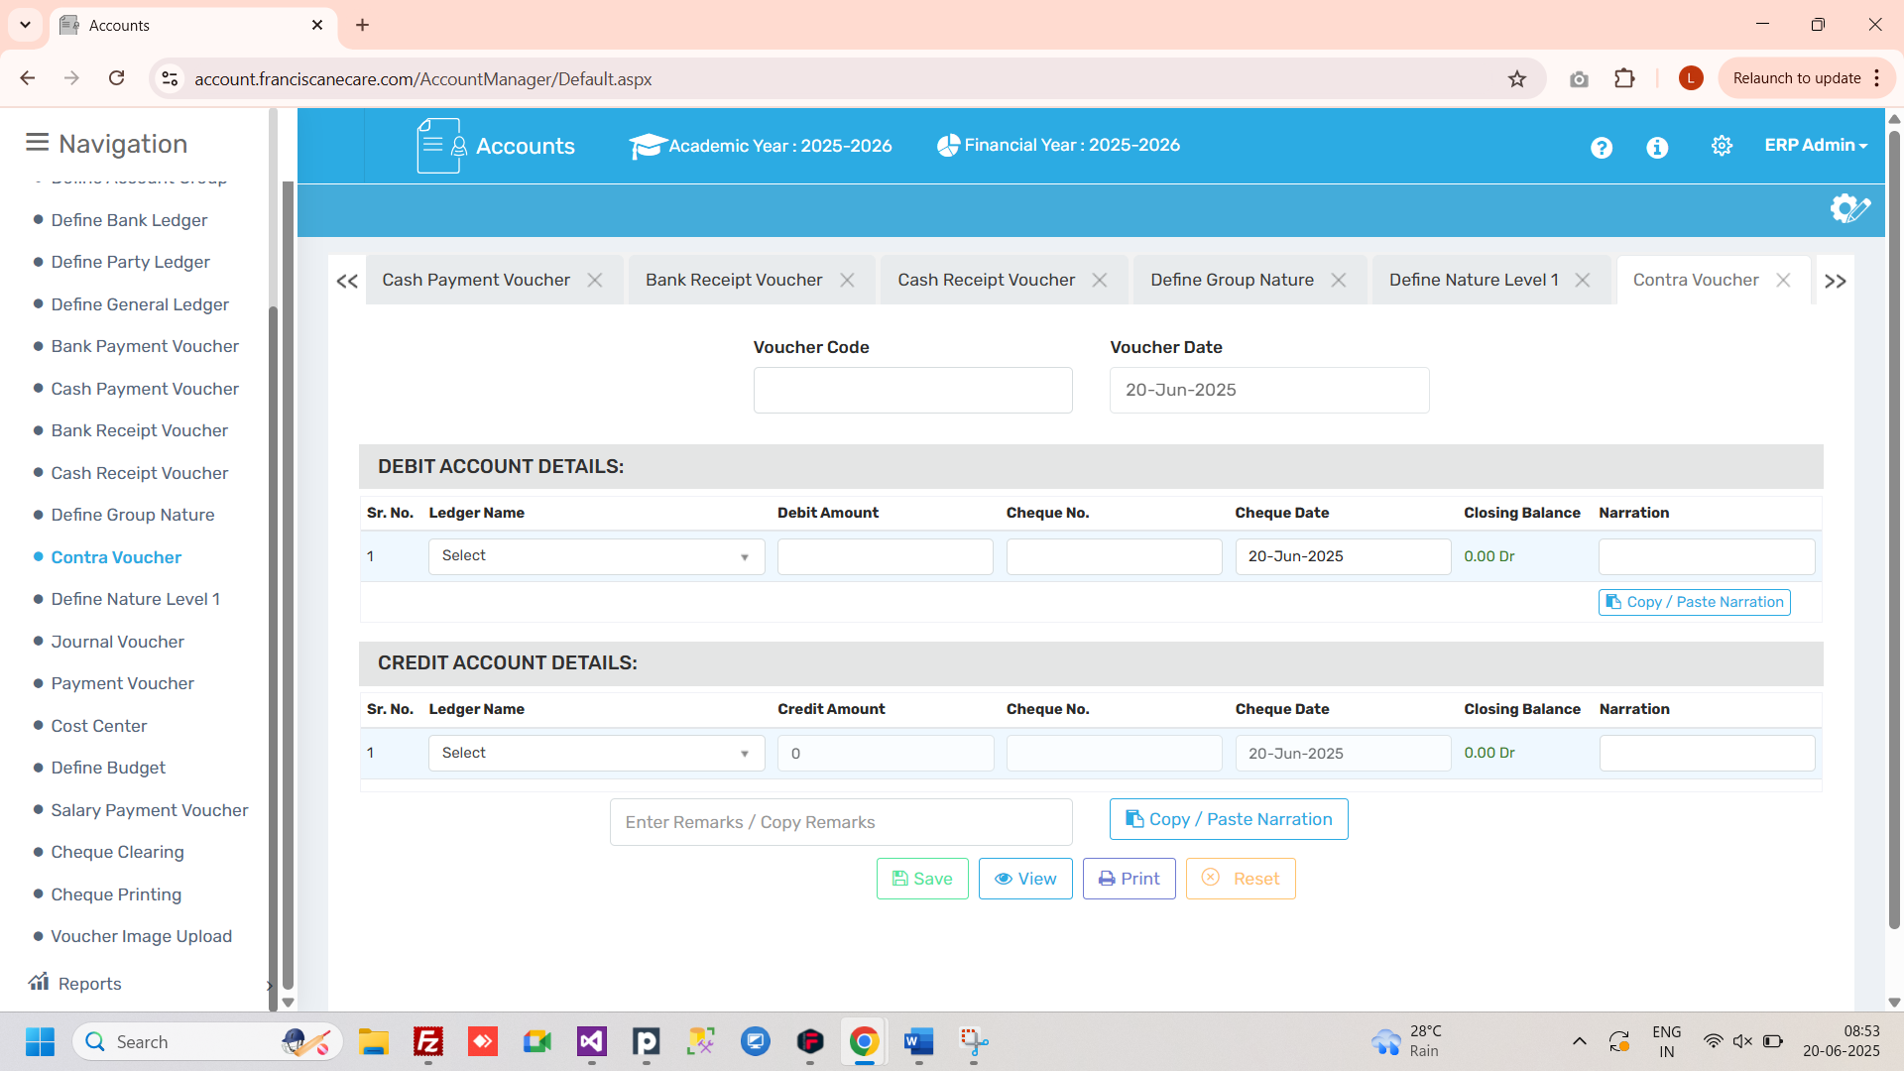

2.11 Define Nature Level 1
Used to define higher-level categories for ledgers to support report structuring.
🧭 Where to Find It
Navigate to:
Account Module → Define Nature Level 1
✅ Use Case
-
⚠️ Important Notes
-
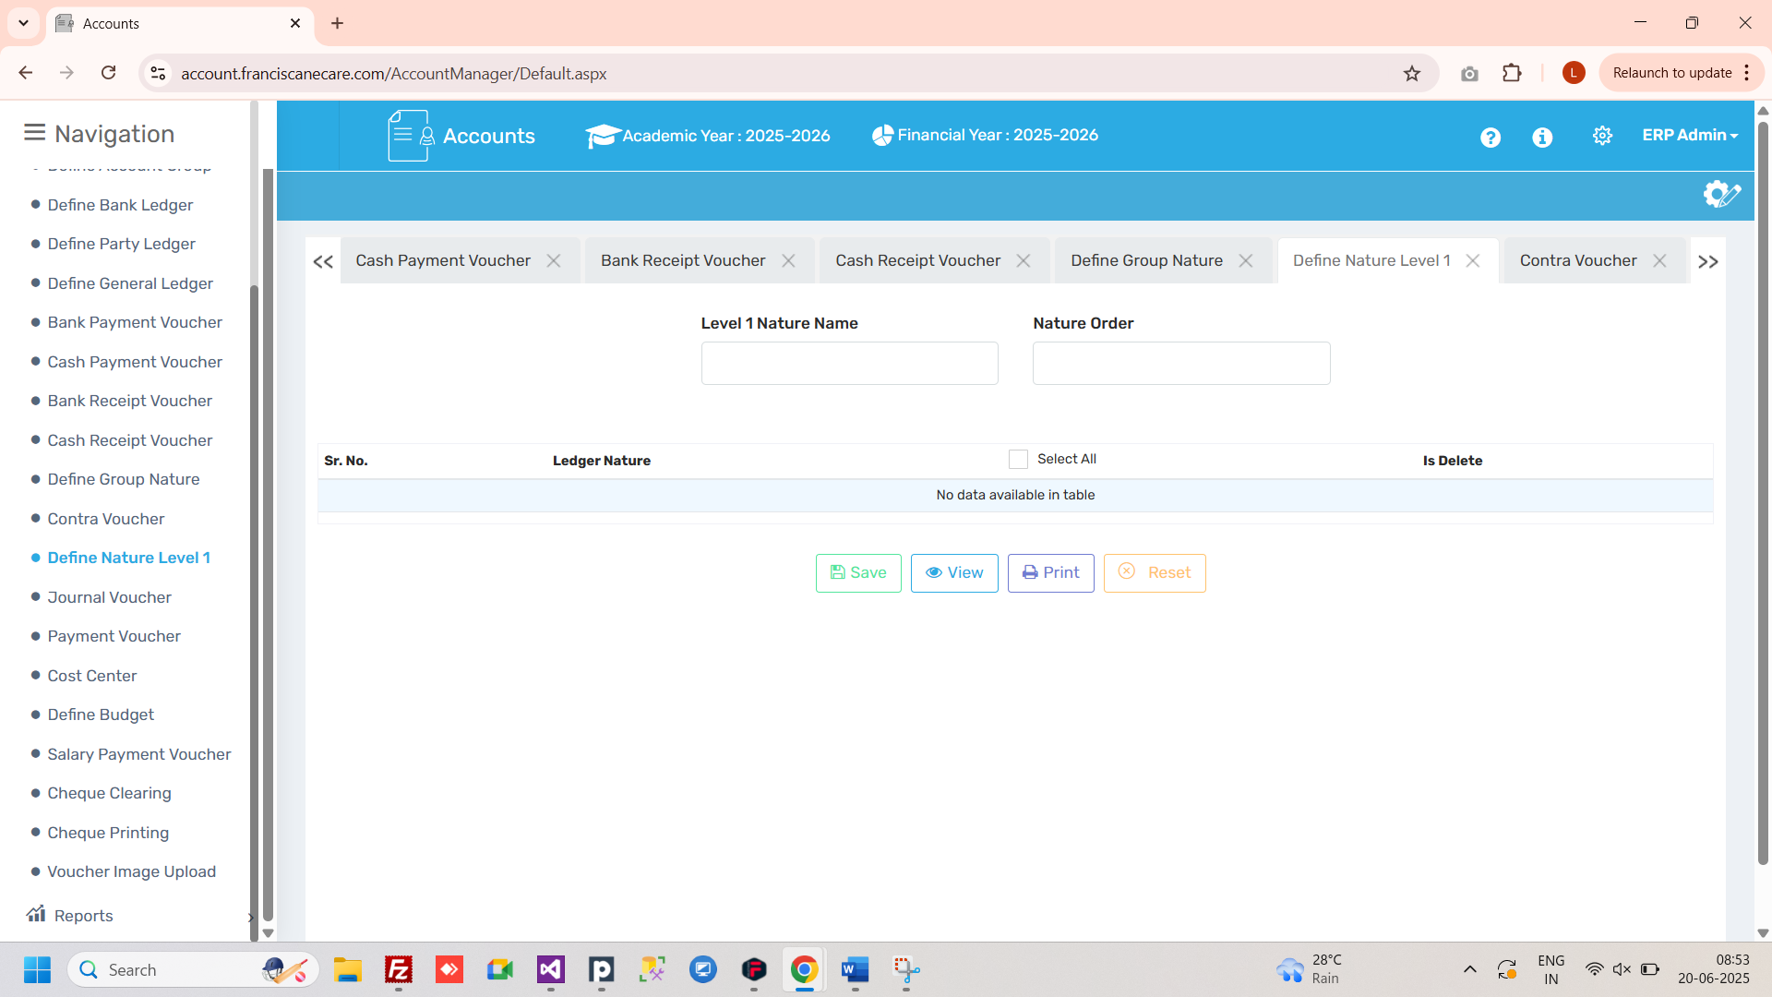
.

2.12 Journal Voucher
Used to record adjustments or internal financial entries that don’t involve cash or bank.
🧭 Where to Find It
Navigate to:
Account Module → Journal Voucher
✅ Use Case
A Journal Voucher is used to record non-cash transactions or adjustment entries that do not involve direct cash or bank movement, but still affect the accounts.
⚠️ Important Notes
Should be backed by notes or internal approval documentation.
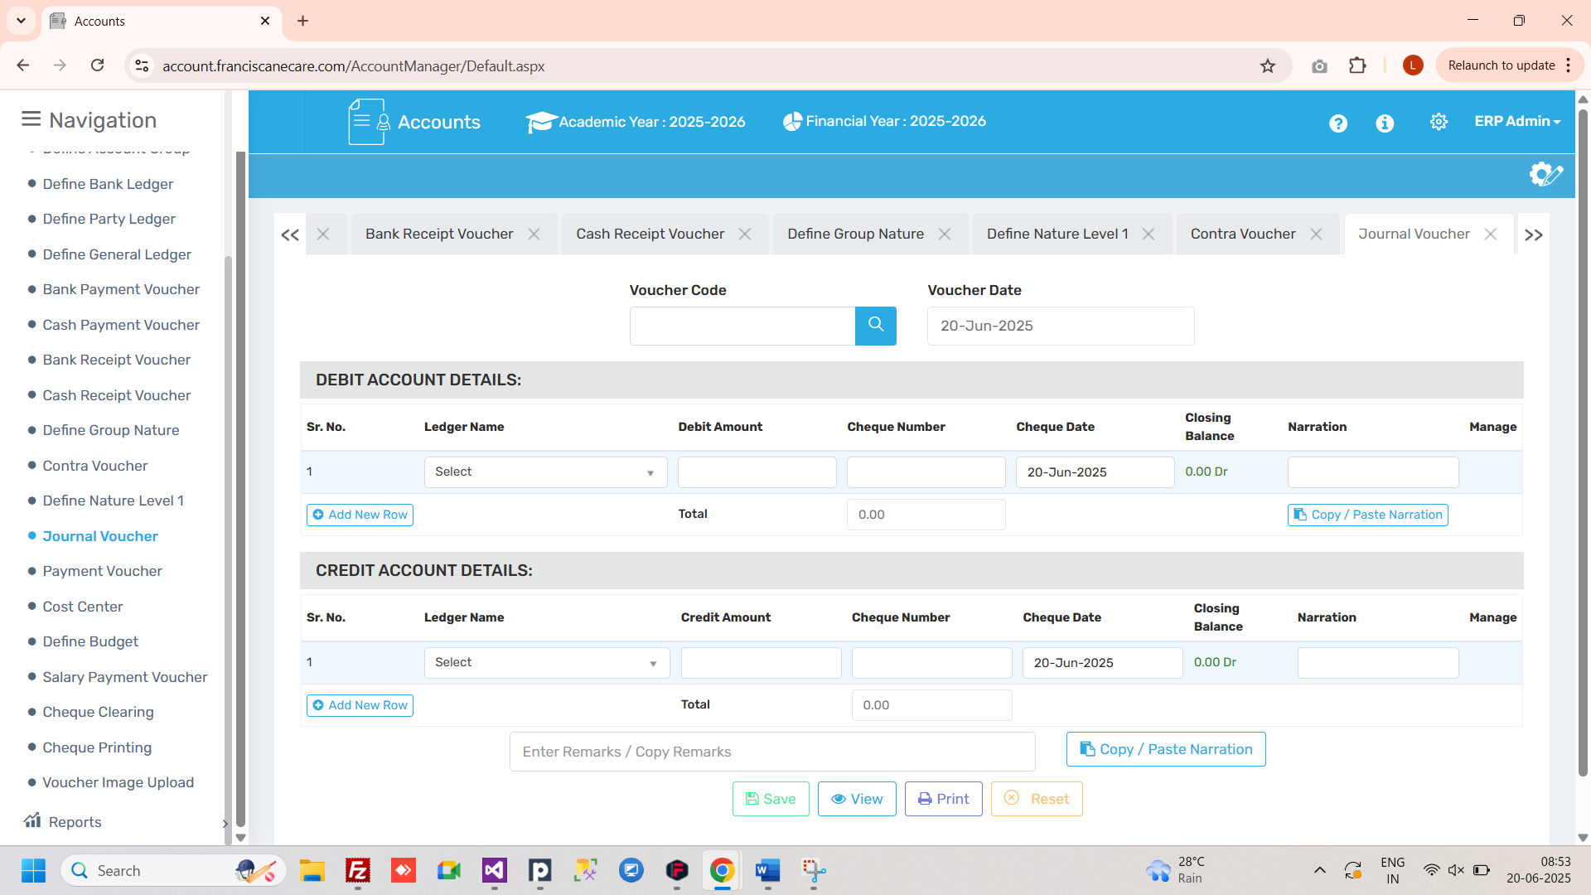

2.13 Payment Voucher
Used to record all types of payments made to external parties or vendors.
🧭 Where to Find It
Navigate to:
Account Module → Payment Voucher
✅ Use Case
Payment Voucher is a way to record the payments made to the institution and maintain the history of payments that the client had made to the institution.
⚠️ Important Notes
Mention invoice details or purpose clearly in narration.
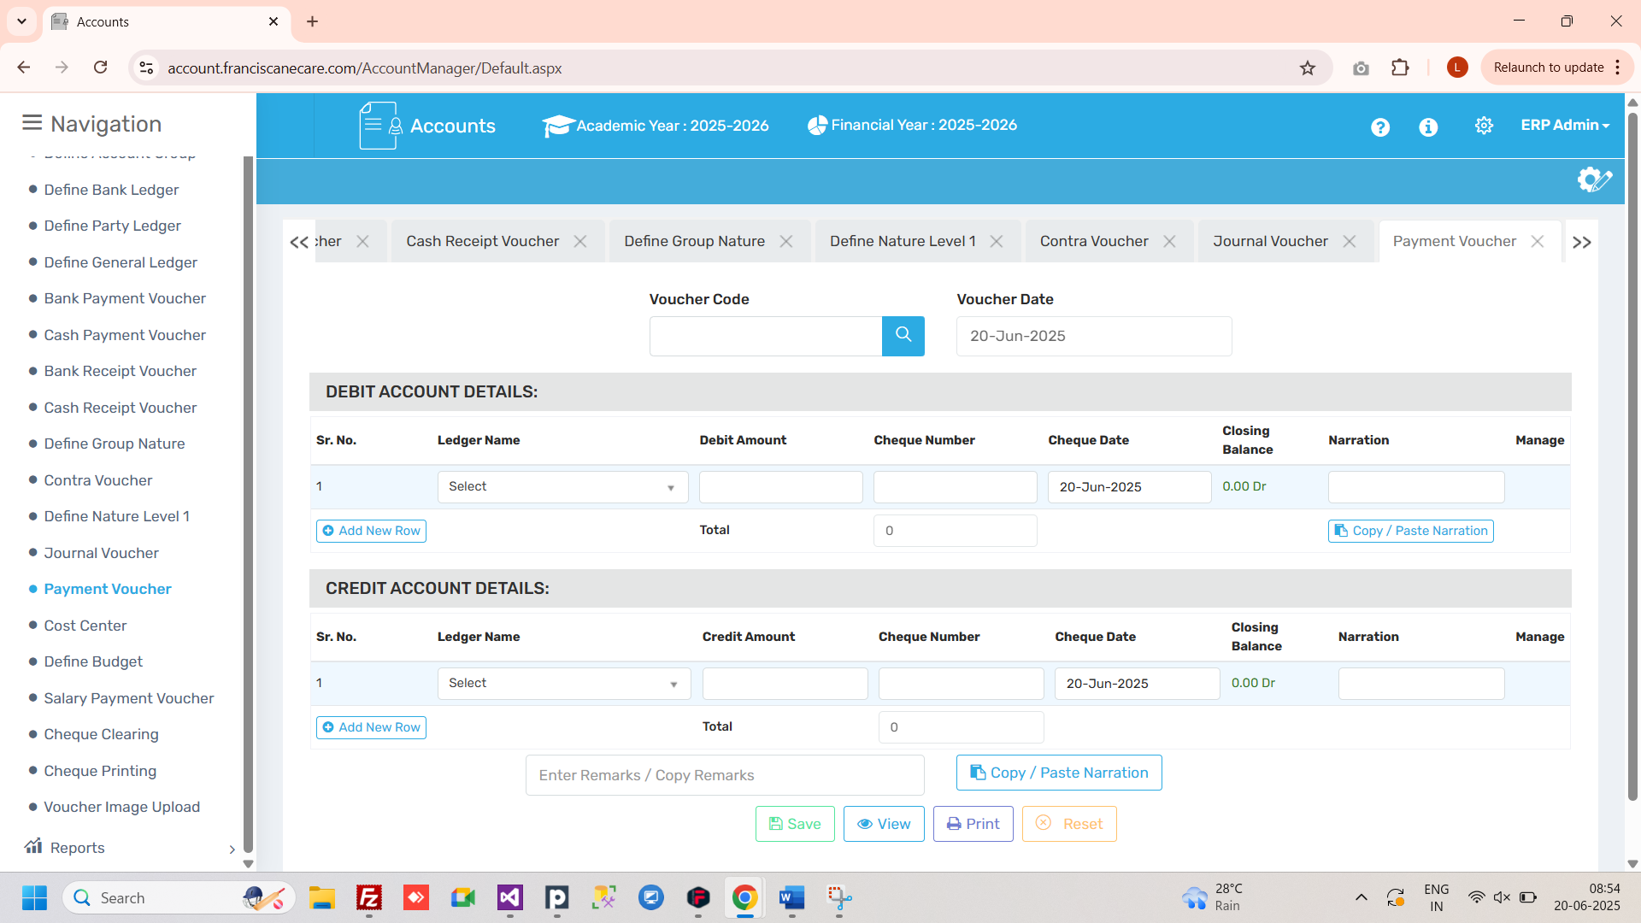

2.14 Cost Centre
Used to track spending for particular departments or projects like Library, Sports, or IT.
🧭 Where to Find It
Navigate to:
Account Module → Cost Centre
✅ Use Case
Cost Center is used to track the actual expenses for comparison to the budget.
⚠️ Important Notes
Helps compare actual spend vs. planned spend department-wise.
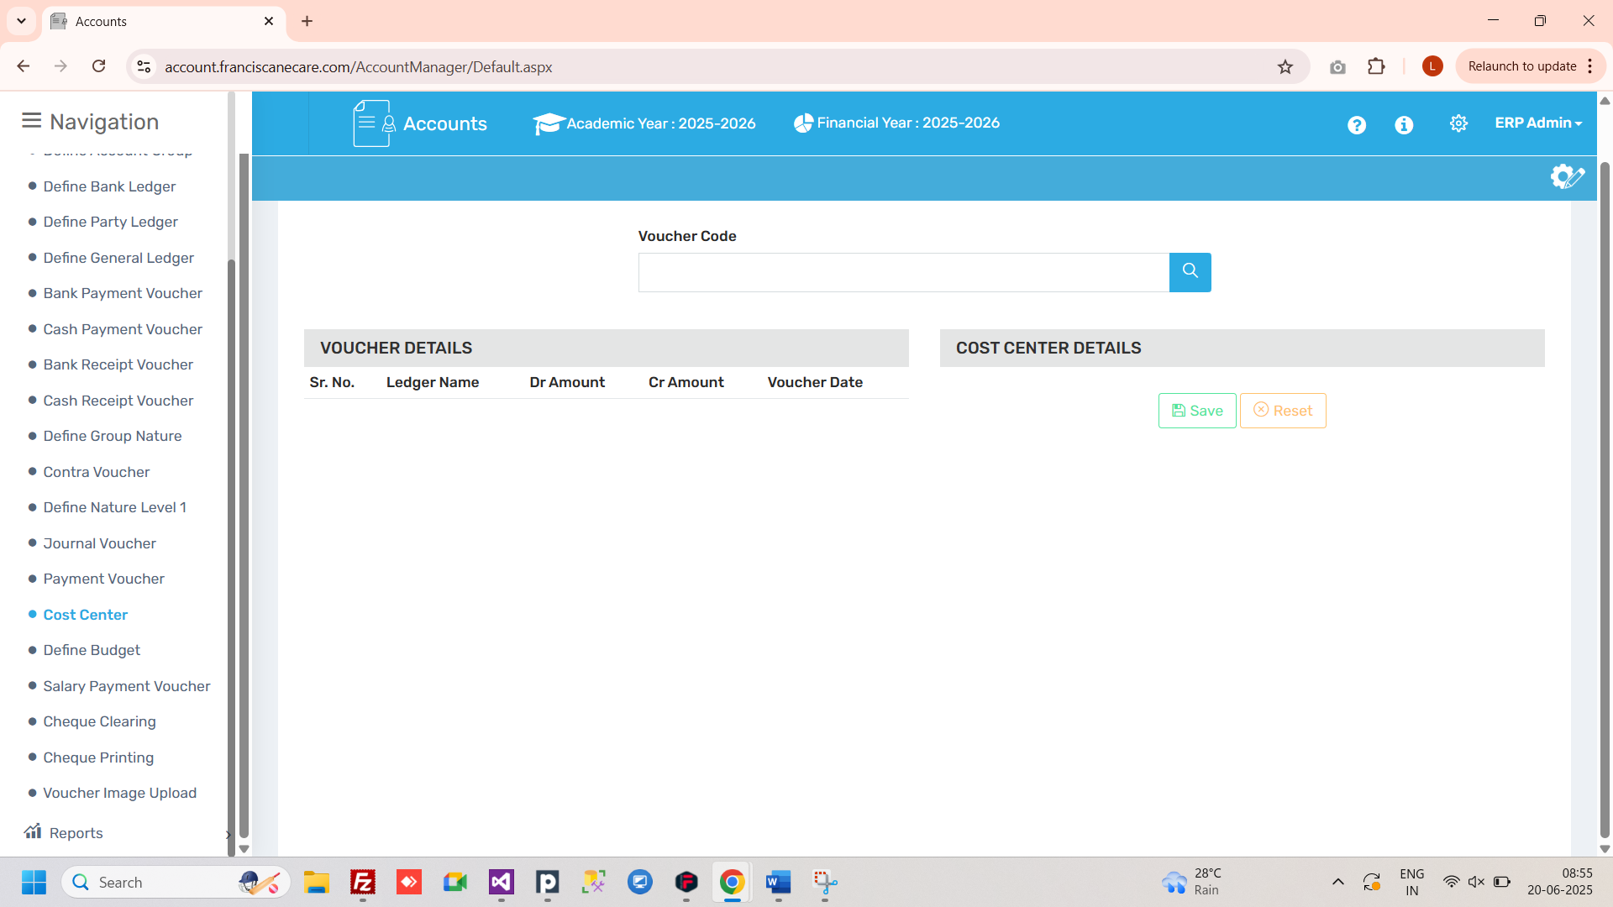

2.15 Define Budget
Allows users to define income and expense limits for financial planning.
🧭 Where to Find It
Navigate to:
Account Module → Define Budget
✅ Use Case
We can define the spending plans based on income and expenses. Set a limit for expenses or income.
⚠️ Important Notes
Overspending alerts can be triggered based on defined budgets.
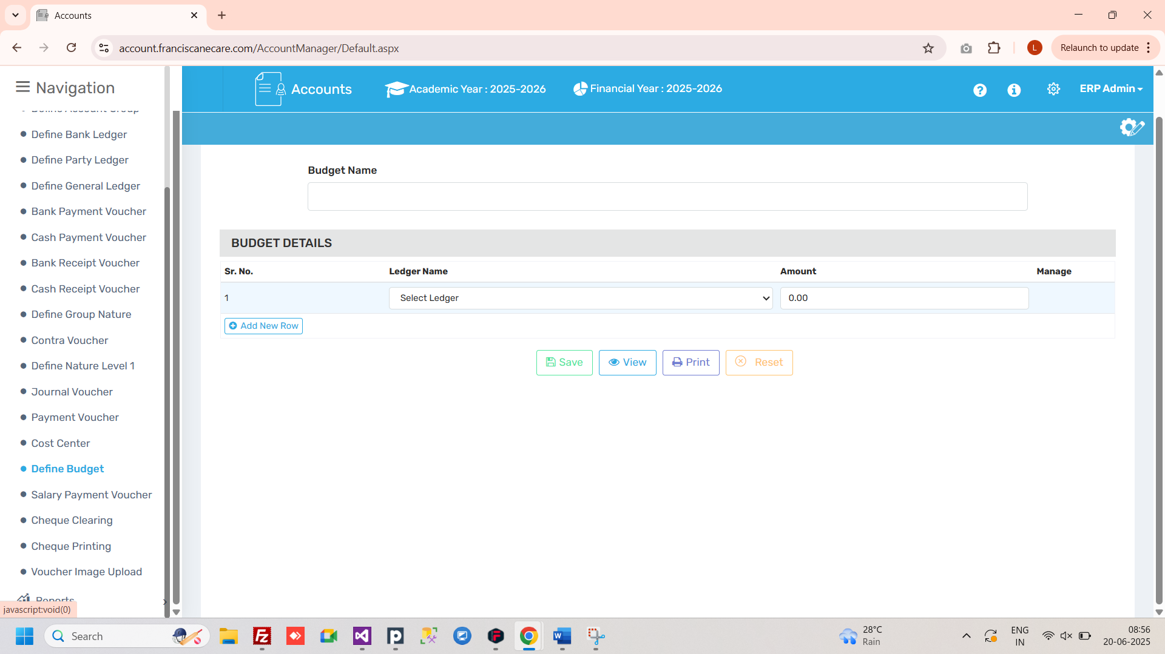

2.16 Salary Payment Voucher
Used for recording the payment of employee salaries.
🧭 Where to Find It
Navigate to:
Account Module → Salary Payment Voucher
✅ Use Case
Disburse and record monthly salary transactions.
⚠️ Important Notes
Ensure correct month, employee ledger, and bank mapping.
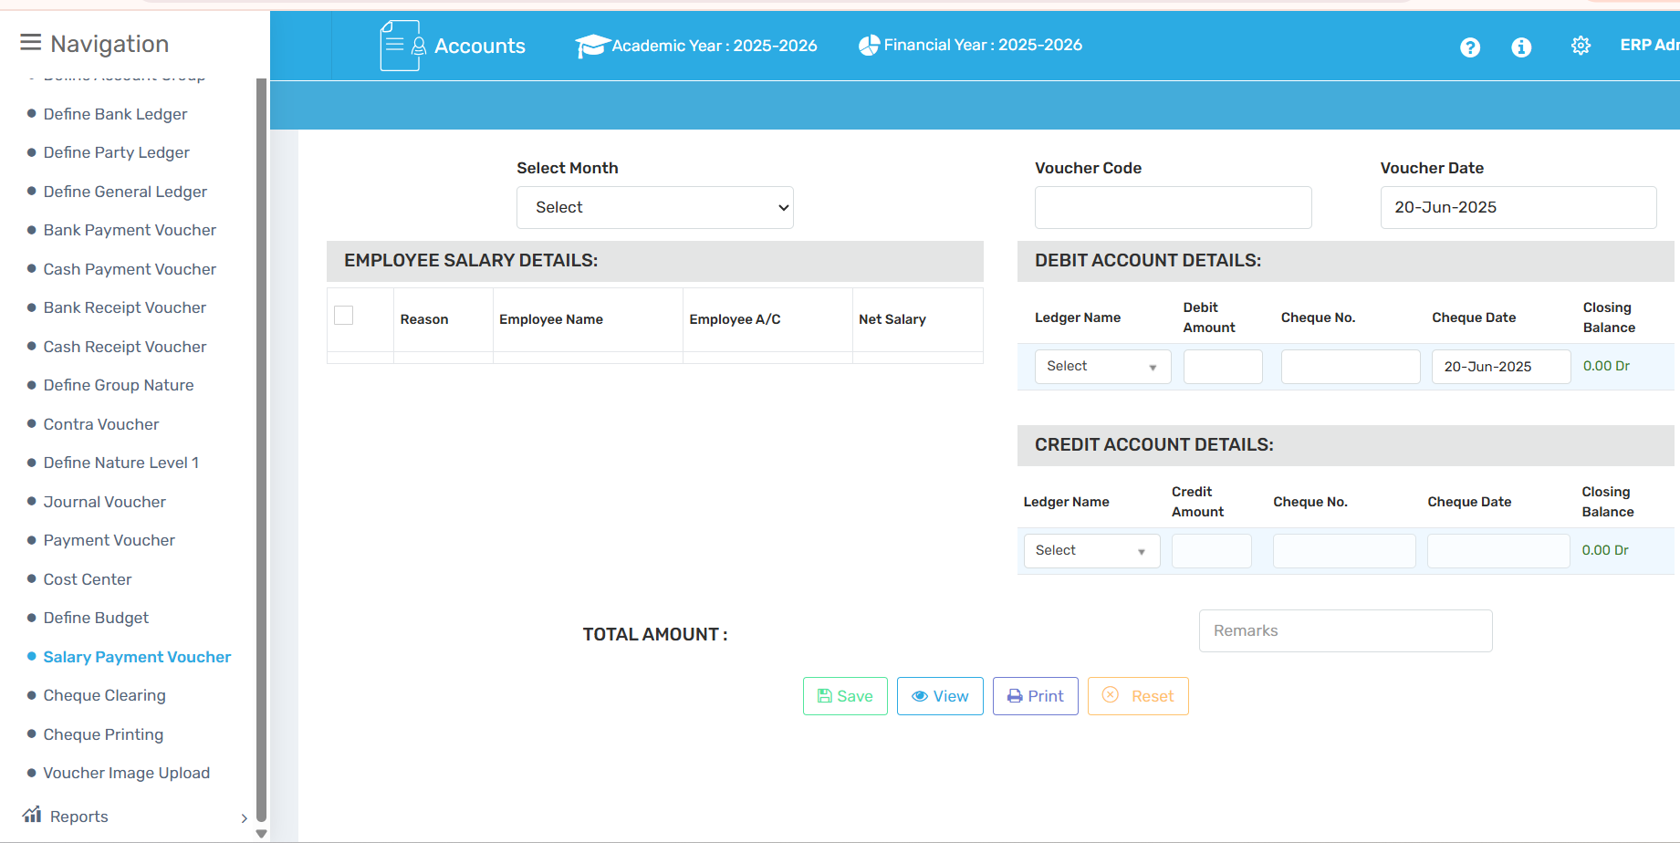

2.17 Cheque Clearing
Used to verify, approve, and settle issued cheques.
🧭 Where to Find It
Navigate to:
Account Module → Cheque Clearing
✅ Use Case
Process of verifying and settling issued cheques.
⚠️ Important Notes
Status change ensures cheque doesn't show as pending in reports.
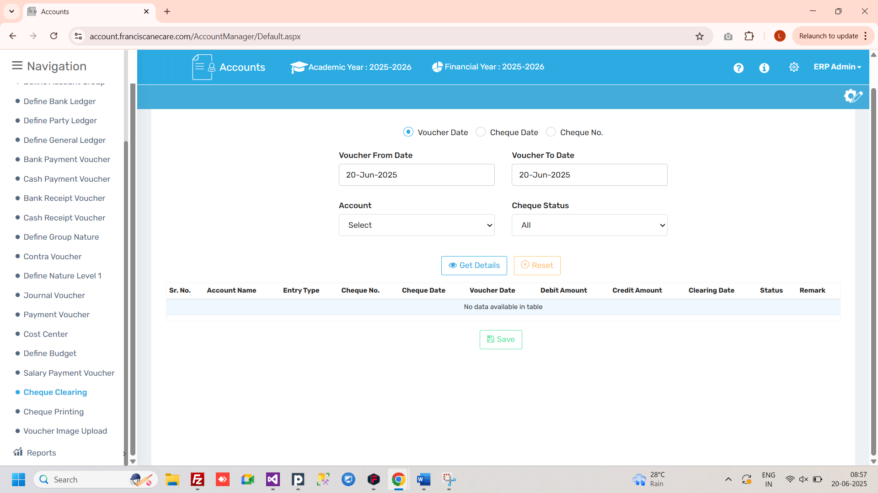

2.18 Cheque Printing
Allows you to print cheques directly from the system using the set format.
🧭 Where to Find It
Navigate to:
Account Module → Cheque Printing
✅ Use Case
Option to print cheques directly from the software.
⚠️ Important Notes
Check alignment before printing on original cheque stock.
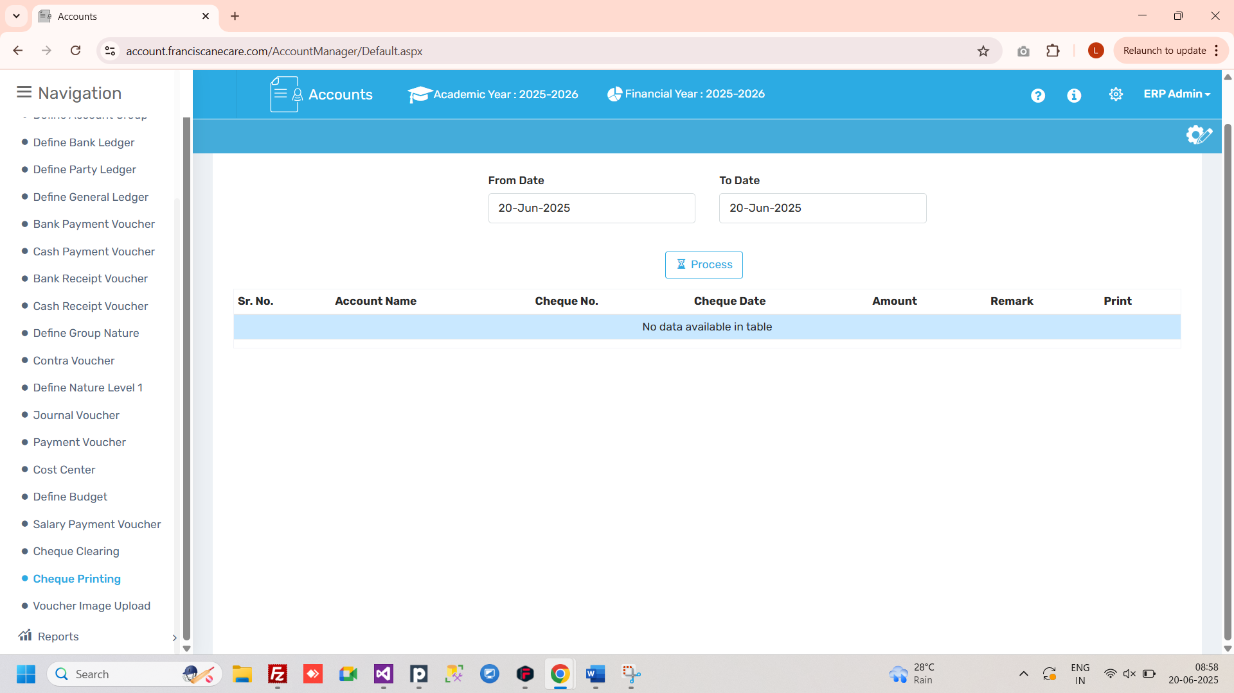

2.19 Voucher Image Upload
Used to upload scanned copies of actual vouchers or bills as digital proof.
🧭 Where to Find It
Navigate to:
Account Module → Voucher Image Upload
✅ Use Case
Attach proof of expense or bill along with voucher entry.
⚠️ Important Notes
- Accepts image or PDF formats only.
- Uploaded documents assist in audits and digital tracking.
- File must be clear and match the correct voucher.
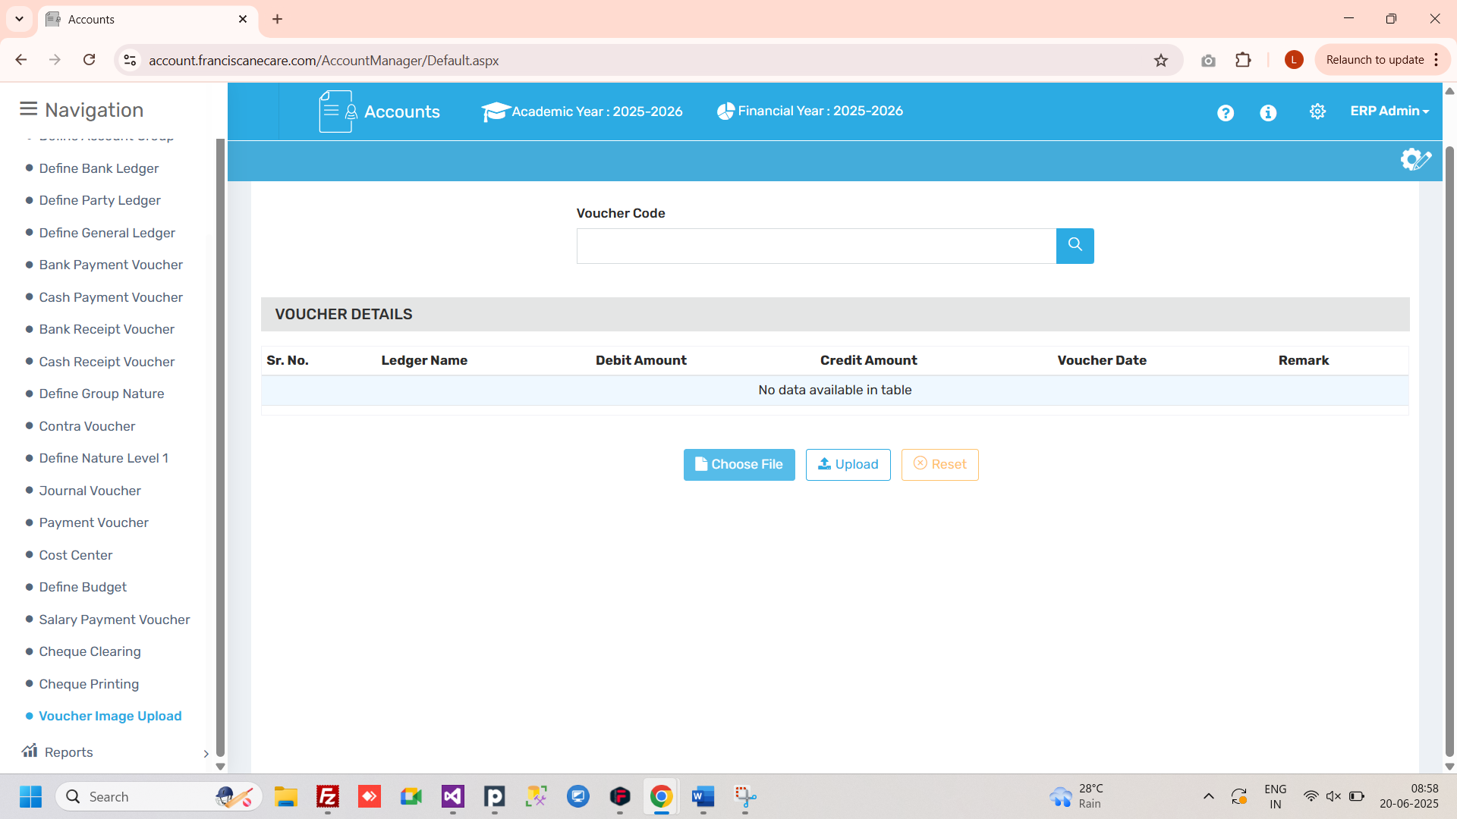

3.1 Reports- You can see different different report from this section

